CHAPTER I

INTRODUCTION

**Project Context**

The Public Employment Service Office (PESO) is a non-fee-charging multidimensional employment service facility or entity established in all Local Government Units (LGUs) in collaboration with the Department of Labor and Employment (DOLE) in accordance with R.A. No. 8759, also known as the PESO Act of 1999, as amended by R.A. No. PESO's goal is to fill employment openings through job recommendation and placement, career counseling, trainings, and seminars. It serves a wide range of people, including job seekers, employers, students, out-of-school adolescents, migrant workers, and people with disabilities. The City PESO encounters a problem regarding their services on how they will be able to monitor and expand its scope for every citizen who wants to comply and be member of their organizations. Tracking their scholar`s status after they graduated, job fair scheduling for face-to-face interview. They only have one admin account that is used for monitoring, tracking, and profiling.

Websites are created appropriately and deliberately as a promotional tool to stand out from the crowd. Because it can be viewed through the internet, they use them to reach a global audience. It is typically only accessible to users for glimpses of what is inside the pages. The use of the computer has increased significantly as time has gone on including its advanced that is helpful for everyone especially in a workplace. Internet-powered modern technology and ideas have increased everything's usefulness and productivity. Websites are used to connect with users in order to convince them as well as to showcase goods and services. According to Mifsud, J. (2011), a company typically sets its usability goals through a combination of user profiling. Esmeria, G. J., & Seva, R. (2017) supports the idea as she claims that “The dependability of several web applications has become more important to the users. Davis (2018). Stated that the infrastructure of information technology makes up an organization. Pastor, C. K. (2020). The effectiveness of the organization depends on the management information system. ThePD (2018, December 11). The office Inform System (OIS) is a cutting-edge word processing system that consists of hardware, software, and procedures. Daryl (2019). Through this web-based system a lot of opportunities can be discovered, and it can be easily accessed by the employee from the office to be more updated. ThePD (2018). Information system is a conceptual overview of a statistical system, which entails the gathering, storing, transforming, and disseminating of statistical data. Solomon (2019) effects of Web-based technologies on knowledge transmission, specifically investigating if using Web-based services might improve problem-solving abilities. It is simple to see how management information systems' capacities to gather, analyze, process, and publish information and data relate to both services and organizations. Ismagilova, E., Hughes, L., Dwivedi, Y. K., & Raman, K. R. (2019). Kcsitglobal.com. (2021). Instead of utilizing an application that is installed on a stand-alone computer, users can access the application from any computer connected to the Internet or Intranet.

This study will provide a solution for information on various studies, profiling, and organizations that seek to identify and reach potential targets through a web-based computerized system. A website should be of high quality which includes a lot of features containing all the services of the office department in PESO for information and reports to achieve this goal. To create a Provincial PESO Services Management System an official website in Calapan City, Oriental Mindoro for their department`s reports, profiling, and information.

**Objectives of the Study**

The main goal of this study is to develop a website: Provincial PESO Services Management System in Calapan City, Oriental Mindoro.

Specifically, it aims to:

1. Create an official website of the PPESO Calapan City that supports its services.
2. Develop a web-management system that tracks the scholarship grants.
3. Create a scheduling module to manage face-to-face interviews for the applicants of PESO.
4. Integrate SMS and email notifications for account verifications and system announcements.
5. Develop a platform that generates reports of scholarship graduates, job fair applicants, and OFW workers.

**Scope and Limitation of the Study**

The scope of this study includes the registration of the employees of PPESO and clients on the website. This official website is only visible for the department PPESO Calapan City Oriental Mindoro. The system can track the status of the students that are under their scholarship graduates. Face-to-face interview scheduling is created in this system to limit the crowd experience in their office. Each PPESO service has separate admin accounts for the employee who handles it and has only one super admin account who can view and monitor anything in the system. For verifications and notification, integrated SMS and email were considered for system announcements.

The following is included in the study's delimitation: (a) with no other departments involved, this study is only for the Department of PESO. (b) The study's specific aspects are only available to its official members, (c) Even with its restricted capabilities, the website can also be access by the citizens who wants to be part of their services by filling up through online but cannot access all the system`s features, (d) no online payment transaction.

**Significance of the Study**

The study will be considered beneficial to the following:

**Calapan City Provincial PESO.** The study's findings would increase the organization's exposure, promotion and will help the department consume less time in work.People will become more interested in the services and recognize the community as one that is developed.

**PESO Administration.** The administration will be assisted in managing the association through the creation of a private setting where members can interact and discuss crucial issues for the good of the organization.  The management of all the association's planned events and programs for its members and in people will be greatly helped by this website and information system.

**PESO EMPLOYEES.** They can use all of the services provided by PESO because they belong to the designated organization. This proposed system will help them to become more computer literate, having assurance that all their records and reports are being kept and will not be easily destroyed, unlike paper-based work. They will also be informed of all news and events and help them less their working hours.

**PESO Clients.** They can be easily informed about the activities, service offers and opportunities, latest updates and contact the employees of PESO just by visiting the official website of Provincial City PESO in Calapan City.

**Researchers.** Enhance their capacity to interact with formal organization decisions. They will be able to evaluate their knowledge of information digital literacy, especially in website development.

**Future Researchers.** It will serve as a resource and guide for prospective researchers as they create websites to support their own and other researchers' studies.

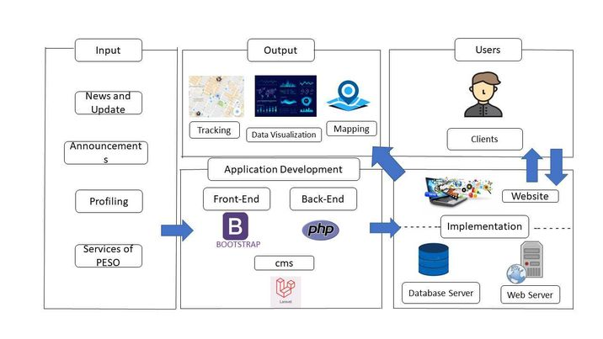**Conceptual Framework**

**Figure 1. Conceptual Framework of the Study**

The goal of this research is to create the Provincial PESO Services Management System's official website. The input comes from the user's access to the various sorts of information on the website and their capacity to engage in activities and services with other users. To make sure the website could function properly, it was carefully and methodically developed. The researchers must be able to design the PESO official Website in accordance with the process for developing the methodology and evaluate the project to make necessary improvements before release.

**Definition of Terms**

**Asynchronous JavaScript and XML (Ajax)** - Since only short data packets are exchanged with the server and web pages are not refreshed every time a user changes their input, asynchronous JavaScript and XML (Ajax) is utilized to make websites appear more responsive.

**Bootstrap 5** - The researchers utilized the most recent Bootstrap version, Bootstrap 5, because it has a quicker style sheet and is more responsive. The most recent, stable versions of all major browsers and systems are supported by Bootstrap 5.

**Information system** - an integrated system of parts for gathering, storing, and processing data as well as for delivering knowledge, information, and digital goods.

**Javascript** - The researchers employed JavaScript to build drop-down menus, form validation, and real-time data presentation to make webpages dynamic.

**Json** - To communicate data between computers, plain text is written in JavaScript object notation, a flexible data format.

**Leaflet** – The best JavaScript library for mobile-friendly interactive maps is called Leaflet.

**Management system** - set of rules, regulations, and guidelines that an organization uses to guarantee that it can carry out the duties necessary to meet its goals.

**News** - the various news stories pertaining to the association and the PESO in general.

**PESO** – Provincial Employment Service Office

**Twilio** - provides building blocks for APIs that assist developers in addressing consumer communication issues and producing creative, user-friendly communication solutions, including SMS verification.

**Website** - a group of websites with a single purpose for an organization. A website may have several features that are necessary to accomplish a task to serve a particular user.

**CHAPTER II**

**REVIEW OF RELATED LITERATURE/SYSTEM**

This chapter reviews relevant information to give the researchers a solid framework for their study. To ensure the reliability and quality of the data gathered, the researchers collected material from reputable academic websites. These will clear the way for the researchers to create a thorough and well-organized capstone project that is connected to the stated goals of this research.

**Related Literature**

Davis (2019). Stated that the infrastructure of information technology makes up an organization. Application systems, and information-using individuals using technology to provide communication and information services for processing transactions, running operations, and managing of an organization. The system makes use of a computer software and hardware for communications, manual processes, and both internal and external data storage facilities. The programs use a mix of automation resulting from user and human actions machine to machine.

Pastor, C. K. (2020). The effectiveness of the organization depends on the management information system. Every organization's management information system should operate in accordance with its goals and objectives.

ThePD (2019, December 11). The office Inform System (OIS) is a cutting-edge word processing system that consists of hardware, software and procedures. It offers technical assistance and support for the prompt retrieval of accurate information by computerized systems to facilitate efficient service planning, operation and monitoring.

ThePD (2019). Information system is a conceptual overview of a statistical system, which entails the gathering, storing, transforming, and disseminating of statistical data.

(Adebayo, 2019). It is likely that poor organizational planning, inappropriate decision-making, inadequate prioritization of needs, and improper programming or scheduling of activities would result if the pertinent information needed for decision-making or organization planning is not available at the appropriate time. This means through a system, prioritizing a planning and updating is easy than doing it manually.

Web support systems could in the broadest sense, serve a variety of web-based activities, including those that are typical of web-based business applications. Daryl (2019). Through this web-based system a lot of opportunities can be discovered, and it can be easily accessed by the employee from the office to be more updated.

According to Rapid Crews (2019). A study by Global Workplace Analytics found that employees of Fortune 1000 organizations worldwide spend 50–60% of their time away from their desks. Thanks to web apps, they may access the office from anywhere.

Web-based apps offer a wide range of business advantages over desktop programs. Instead, than needing to be manually installed on each machine you desire to access it from, these programs can be accessible from any computer through the internet. Chairman, P. K. (n.d.) (2020).

Acoba, Cunanan, Merencilla, Tejada, Ligayo (2020). In terms of e-government support programs such online transactions, e-filing, e-learning, e-passports, and other e-government related activities, the nation is currently viewed as a global showcase of socioeconomic progress. The e-government promotes governance models that must improve operational performance, transparency and accountability, enhanced community involvement, and successful public service delivery.

Solomon (2019) effects of Web-based technologies on knowledge transmission, specifically investigating if using Web-based services might improve problem-solving abilities. Numerous organizations are actively working to develop services that promote knowledge transfer because it has been demonstrated that it directly correlates with industrial productivity.

You and your sales team can access customer and prospect information from any location with a web based. Sales managers can still assign leads to the appropriate sales representatives and quickly generate unique quotations for each lead. The sales team can also decide when to follow up with prospects based on their priorities. You can keep an eye on every sales activity. You may examine emails exchanged between each salesperson and the leads they are working with from your sales reps' progress, allowing the sales process to continue as usual. Kanya (2022).

Martin (2019). Computers are now a necessary tool for many office-based professional vocations, but their use also results in changes to the workload and psychosocial aspects of the workplace.

According to Scott Morton. (2019), information processing specifications that depending on those organizational variables, they can change and have significant implications for defining the position of IS in businesses.

It is simple to see how management information systems' capacities to gather, analyse, process, and publish information and data relate to both services and organizations. Ismagilova, E., Hughes, L., Dwivedi, Y. K., & Raman, K. R. (2019).

Lyytinen & Newman (2020, p. 4) A system of organizations that combines technical and organizational and enlarged and reorganized semiotic components. Serving an objective during ISD (information system development) organizational objectives.

The addition of an information system to a firm can have a number of advantages and help with both the routine internal and external business procedures as well as future decision-making. Ecpi.edu. (2022)

Magic Web Solutions. (2022). Web systems, in contrast to traditional applications, are accessible whenever, anywhere, and from any PC with an Internet connection. Because of this, the user is in complete control of how and when they access the application. This enhances the user's capacity to take in information and interact with it in a way that works for them.

Kcsitglobal.com. (2021). Instead of utilizing an application that is installed on a stand-alone computer, users can access the application from any computer connected to the Internet or Intranet.

Laudon and Laudon (2019). MIS is described as "the study of information systems focusing on their use in business and management" by those who have defined the term. The definitions listed above demonstrated how MIS has prioritized the creation, use, and validation of pertinent theories and models to support high-quality research in the field.

All the data information from the citizens that needs to be recorded by the department of PESO needs to be stored properly making sure that no records will be lost. According to Baskerville and Myers (2019). "The creation, utilization, and application of information systems by people, groups, and society."

From one of the PESO`s services, scholarship is known to be the most helpful one. They need to gather information from the students to track their grades or if they meet the standards. Whitten et al. (2019, p.12.) stated that "Information is an arrangement of people, data, processes, and information technology that interacts to gather, process, store, and provide as output the information required to support an organization."

The field of study known as Web-based Support Systems (WSS) focuses on ways to support diverse human activities using the Web as a user interface. It can be seen as a type of multidisciplinary research that combines studies of certain domains with those from other fields, such computer science, information systems, and web technology. Jingtao Yao, (2019).

Hasan Hariri, (2021). A favorable environment is created for the establishment of the scientific research management information system by the advancement of internet technology and applications. Many businesses and nations have conducted research on the impact of web-based management information systems on the development of services.

k-wp, S. (2019) Stated that with web-based technologies, data sharing and project collaboration are simpler. Users can share data and collaborate on projects since data is kept in a single, central location. Additionally, it is simpler to incorporate web-based solutions than standalone desktop programs.

Evergreen (n.d.) (2022). Your business processes can be streamlined with the aid of web applications, allowing you to complete more tasks more quickly and accurately. Additionally, having all your data in one location gives you better insight into your company, frees up staff time, and enables you to run reports that are updated with real-time data.

Software that runs on the web may also be adaptable to browser changes. This encourages mobile working and guarantees that staff always have access to the program. Paymon Khamooshi(2019).

Arasasingham et al., (2019). Additionally, learning settings can promote process skills, encourage directed problem-solving, and demonstrate effective problem-solving techniques. Software that is designed properly. Materials can aid kids in creating connections in their minds to develop their logical acquiring a mastery-level understanding of chemical concepts and concepts.

There has been unrest within a certain institution's graduating class due to the absence of an information system that would offer data about alumni. The event will only take place if the alumni data is updated. If an information system can offer the relevant details, the agencies and graduates who require information can get the required data. (Yunanto et al., 2019)

According to Lazer et al. (2019), the rise in false news has circulated inaccurate information online. The entire world is impacted by this problem. Malicious actors' manipulation of information has an impact on society as a whole, as well as on people and institutions. The recommendation is that a website must be put into place in order to communicate the news.

Mena, P. (2020), flagging false news has been a method of preventing people from disseminating false news on social media. Numerous projects aimed at giving internet news sources legitimacy labels have been launched in recent years. Using an experimental approach, this study evaluates the potency of labels intended to stop the spread of incorrect information. The researchers discovered that by lowering the trustworthiness of incorrect information, flagging false news may lessen intentions to spread false news.

**Synthesis**

The studies mentioned above demonstrate the value of a web-based management system and platform for office tasks. The widespread usage of the use of internet platforms has become inevitable because of the use of internet platforms like social media to communicate information to the general population. It was discovered that adopting an information system might help the neighborhood create a platform that limits the spread of false information and securely stores data. The usage of interactive technologies will make it easier to build a website with many users and pages, which will assist the spread of advertisements for new products and jobs openings. Information regarding upcoming records, historical records, and scholar pupils can be shown using the information and management system. The earlier studies covered the requirement for a reliable website to provide and distribute information to citizens. The management method aids in boosting news trustworthiness and decreasing false information on social media. Since social media can quickly transmit information, it is regarded as a vital source of information. However, utilizing this type of platform to deliver information carries the risk of misleading people and will allow PPESO personnel to work for less than an hour.

**Bibliography**

Davis(2019)Defining Information Systems as Work Systems_ Implications

Pastor C. (2020) The Role of Management Information System: Review on the Importance of Data and Implementation in Organizational Process

ThePD (2019) Statistical Information System

ThePD (The Project Definition). (2019). Office Information System (OIS). The Project Definition.

Adebayo(2019)The significance of management information systems for enhancing strategic and tactical planning

Daryl(2019) Design Scenarios for Web-Based Management of Online Information

10 benefits of web-based applications and systems. (2019, May 12). Rapid Crews.

Chairman, P. K. (n.d.). (2020, December 19) The benefits of using web-based applications. Ltd.uk.

Acoba A., Cunanan C., Merencilla N., Tejada R., Ligayo M., (November 2020). JuCo-IS: A Development of Web-Based Information System in Judicial Regional Trial Court.

Solomon(2019) The Effects of Web-based Technologies on Knowledge Transfer

Kanya. (2022, August 2). The benefits of web-based apps for businesses amid covid-19 outbreak. BusinessTech; HashMicro.

Martin(2019) Home Physiotherapy Medicine Musculoskeletal Article Literature Review The Impact of a Computerized Work Environment on Professional Occupational Groups and Behavioural and Physiological Risk Factors for Musculoskeletal Symptoms: A Literature Review

Morton, M. S. S. (2019). Implications of Changes in Information Technology for Corporate Strategy.

Ismagilova E, Hughes L, Dwivedi YK et al (2019) Smart cities: Advances in research—An information systems perspective. International Journal of Information Management

Lyytinen & Newman (2018)Defining Information Systems as Work Systems_ Implications

(2022) BUS316 Foundations of Decision Making

(2022) The benefits of web-based applications - Magic Web Solutions. (n.d.). Magic Web Solutions

(2021)The benefits of web applications in todays technological era

Laudon and Laudon (2019) The significance of management information systems for enhancing strategic and tactical planning

Baskerville and Myers (2019) The significance of management information systems for enhancing strategic and tactical planning

Whitten et al. (2019) The significance of management information systems for enhancing strategic and tactical planning

Jingtao Yao(2019) Design of Web-based Support Systems

Setyawati, Eny and Hariri, Hasan (2021) Web-Based Management Information System for Services Development: A Literature Review. International Journal of Current Science Research and Review

k-wp, S. (2019, October 13). The benefits of web-based systems for business. Aezion.

Evergreen. (n.d.) (2022). 5 key benefits of web applications for business.

Paymon Khamooshi(2019)The benefits of using web-based applications

Arasasingham et al., (2019) THE EFFECTS OF THE COMPUTER-BASED INSTRUCTION ON THE ACHIEVEMENT AND PROBLEM SOLVING SKILLS OF THE SCIENCE AND TECHNOLOGY STUDENTS

Purba, N. P., Handyman, D. I., Pribadi, T. D. K., Syakti, A. D., Pranowo, W. S., Harvey, A., & Ihsan, Y. N. (2019).

Allcott, H., Gentzkow, M., & Yu, C. (2019). Trends in the diffusion of misinformation on social media. Research & Politics

Mena, P. (2020). Cleaning Up Social Media: The Effect of Warning Labels on Likelihood of Sharing False News on Facebook. Policy & Internet,

CHAPTER III

METHODOLOGY

This chapter will go over setting up the official PESO website. To enhance the presentation and improve the understanding of the platform's construction, the research methods and approach were described in order to further justify the data collected along with the structural models of the system.

**Development Method**

The "Questionnaires / Survey" research method was employed in this study with the intention of gathering data from the respondents by having them react to questions with pre-written responses, choosing the best one. The researchers adopt this technique because it makes it simple to aggregate and analyze data.

Figure 1 depicts the researchers' use of Agile methodologies to build the project. The process is similar to the waterfall model where it is required to finish every stage before moving on to the next until it finally reaches the implementation / coding stage.

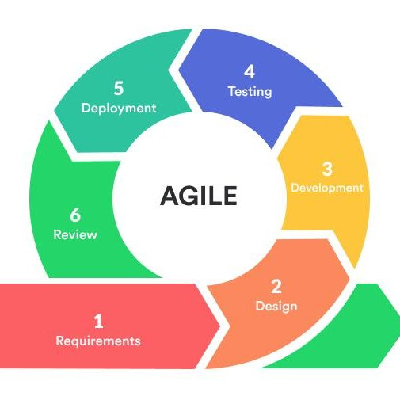

**Figure 1. Agile Model**

The sequential phases in Agile model are:

1. **Requirements** – This stage includes idea generation and project conceptualization. The researchers worked together by talking with one another and making plans for the actions necessary to successfully build and execute this capstone project. The client was actively involved in the planning process to ensure that the desired features and functionalities of the PESO Official Website were understood.
2. **Design –** The details of the creation of the website are the focus of this pahase. From the User interface, which discusses the color scheme that fits the website`s identity, the positioning of the website`s functions, and the pertinent content that should be present on every webpage, to the system`s back end, which discusses the contents of the database, including the table and fields that are essential to the website`s functionality. The researchers took care to identify the users of the website and to ensure that the design and user interface were suitable for all of the targeted users.
3. **Development** – The execution and coding of the website plan come next in the Agile Model's process after all the ones mentioned previously. All of the plans and tests that the website has undergone are put into action in this phase. To enhance the growth to its best potential, this stage should be in touch with the stages that came before it. To make sure that the development is properly refined in accordance with the development process, testing should be conducted again immediately following this step. To make the code readable for the engineers themselves, the researchers adhered to the fundamental coding principle. As everything depends on how well the system is developed to ensure that the website is operating correctly and performs well, the coding process is crucial to the project's success.
4. **Testing** – Each component of the website is specifically evaluated during this stage. From its design to the database, the researcher conducted an in-depth study on the building block of the website to understand more and to help its development. This guarantees that the researchers can examine and comprehend the project more thoroughly.
5. **Deployment** – The solution will be deployed, and the client could now see if it worked well for them. The client will also check if the system was operating properly. The researchers must therefore confirm that the system is operating as intended.
6. **Review** – This guarantees that the system is periodically monitored. The website's functionality and security should be periodically evaluated to maintain system performance.

**Gantt Chart**

Figure 2 depicts the sequential events that took place on the website. The project is being developed in accordance with the Gantt chart to carry out every plan more effectively after developing the website.

**Figure 2 Gantt Chart**

**Requirements Specification**

The users of the proposed project must be competent and correctly oriented to the system to get the most out of it. This covers the software interface, technical specifications, and functional specifications.

**Functional Requirements**

Functionalities concern the system's operation and process. This covers everything from the system's administrator to the website's actual users.

**User Interface**

The PESO Official Website was created with a distinctive appearance using website frameworks to allow visitors to explore the site easily and quickly. The user interface and its features are thoughtfully designed to enhance the user experience and appeal to the user's eyes. Given that it makes interaction between the user and the program easier, the user interface is also an important component of the project. Users can communicate with the system thanks to the user interface. While creating the project, the UI design components were considered. The goal of the designers was to produce a system with an intuitive user interface. It enables the system's end users to operate it successfully. The system's user interface (UI) makes it accessible to users.

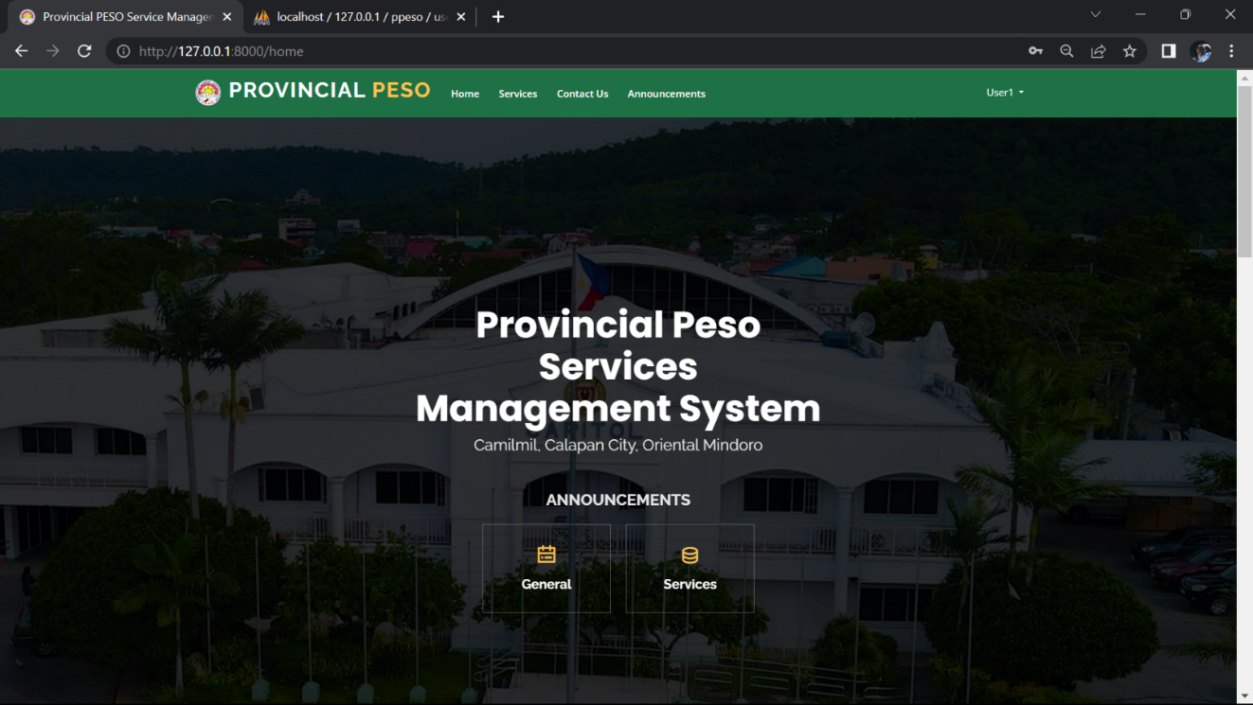

**Figure 3 User Interface**

The project's example interface is depicted in the figure above. It shows the system's home page. When a user first logs in to the system, they will view this landing page.

**Hardware Interface**

The hardware utilized in this project satisfies the requirements set forth for the system to operate correctly. Because they work together to ensure that the developed system performs at its best, the relationship between software and hardware should be always taken into consideration. The website operates on a device with an Intel or Dual-Core CPU version of the processor or a higher version, as well as 2 GB or at least 1 GB of RAM.

**Software Interface**

This project delivers a program that is easy to navigate to the administrator of this platform. It guarantees clarity and effective navigation throughout the entire website. This project is designed to be user-friendly, particularly for PESO employees. The success of the project depends on this interface, which explains how the system interacts with other components like the computer system and database. The researcher utilized the Windows 10 operating system, Google Chrome as their web browser, Visual Studio Code as the system's integrated development environment, XAMPP server to generate databases, and Laravel PHP Framework to help them by offering the most straightforward way to apply modularity methodologies.

**Security Interface**

To stop unauthorized activities that might be carried out by unauthorized users, the system is password-protected. This guarantees that the system won't be compromised by hacker attacks that would be very expensive for both the system and its users. The Laravel PHP Framework's accessible security modules were all enabled by the system.

**Technical Background**

The technical background provides crucial details about the project's technological features. It makes it simpler to specify what is necessary in terms that developers can comprehend. In this section, the system's technical details were explained. Recognizing and researching the technicalities that have been employed is crucial. The project's hardware and software specifications are shown in the following sections. It is essential to consider the system's requirements because they offer an effective means of setting up and running the website on a user's device.

**Hardware Specifications**

The hardware components used by the researchers are listed here along with their specifications. The size, memory, and storage capacities of each component are included in the technical specs.

**Table 1**

**Component’s Specifications**

|  |  |  |  |
| --- | --- | --- | --- |
| **QTY** | **UNIT** | **ITEM** | **SPECIFICATIONS** |
| 1 | pc | Hp Laptop | 15-inch; 4GB RAM; 500 HDD |
| 1 | pc | Acer Laptop | 14-inch; 8GB RAM; 512 HDD |
| 1 | pc | Huawei Laptop | 15.6-inch; 8GB RAM; 512 HDD |

Table 1 displays all the specific information, including the size of each component, the operating system used, and the amount of storage and RAM available.

**Software Specifications**

**Table 2**

**Software Specification**

|  |  |  |
| --- | --- | --- |
| **Software** | **Specifications** | |
| **Minimum** | **Recommended** |
| Operating  System | Windows 7  Ultimate 64-bit | Windows 10  64-bit |
| XAMPP Server | XAMPP version 3.3.0 | XAMPP version 8.2.0 |
| Visual Studio Code | VS Code  version 1.63 | VS Code version 1.63 |

The features of the software utilized for this investigation are displayed in Table 2. For optimum use and production performance, the researchers employed the most recent operating system and versions of the software.

**System Analysis and Design**

To build the website, the researchers were careful to adhere to the development process model. To avoid misunderstanding and mistakes that the development stage can encounter, the researchers assess the design and coding at each level and plan for the upcoming steps that might be taken.

**System Overview**

The creation of the website is meticulously planned out by gathering crucial data and considerations for the client. This study ensured that the website could comply with the desired features and perform as the client had specified. To plan the user interface and function to give simple navigation around the website, the researchers considered the audience that will use the site.

The employee and admin can view the information about the association and updates within the PESO services on the landing page of the PESO Official Website, which is where it will finally be directed. The administrator has access to the entire website and could add, remove, and update data as well as the association's contact details.

They can view the events, updates about their services, track the people who have been active in their programs, and departmental updates on the website. Additionally, they can begin keeping an eye on their fellow citizens online.

The website's design ensures that it considers the consumers who will use it in terms of visual design, simple navigation functions, and convenience of usage. The researchers ensured that the website secures user information by using a solid framework with a simple but excellent structure for creating an online platform like the official website for the PESO Services Management System.

**System Architecture**

Figure 4 shows the system architecture of the PESO department`s Official Website. The employee should register to make them the ADMIN OR JUST AN EMPLOYEE to access all the features and functions of the website.

**Figure 4 System Architecture of PESO Services Management System**

**Use Case Diagram**

The procedure that users must follow on the created website is depicted in Figure 5. This view displays how the user feels about the functionality that the project's backers have supplied.

**Figure 5 Use Case Diagram for the Developed Website**

**Data Flow Diagram (DFD)**

The researchers examined the operational workflow of the existing system and created a data flow diagram to compare and decide on a system improvement. The data flow diagrams will make it easier to understand how data flows inside of a program and between various system operations.

**Figure 6 Data Flow Diagram**

**Diagram 0**

The suggested system`s schematic 0 is displayed in Figure 9. To access the website as an employee or administrator, the user must first register. Now that they have logged in, the user can use the website`s services.

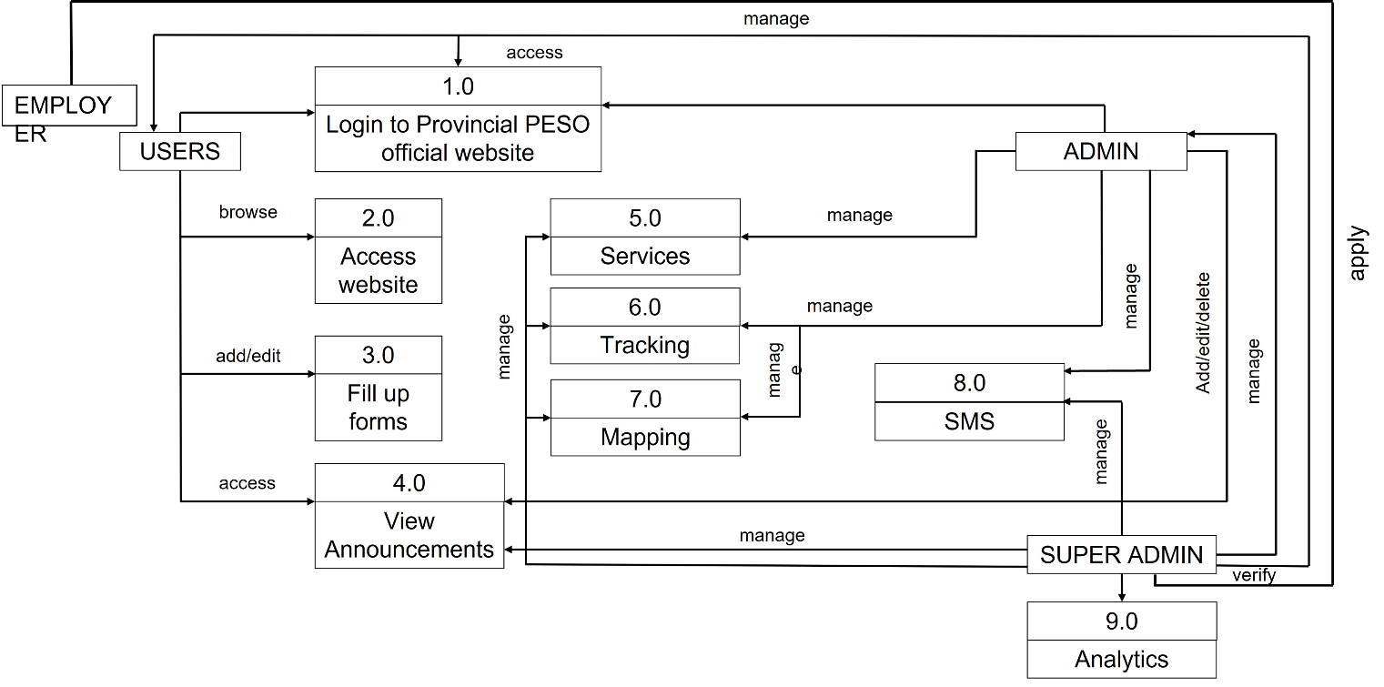

**Figure 7 Diagram 0**

**Database Schema**

One of the important phases of website development is the design of the database which contains the different entities in the website. This provides the users with the attributes of existing entities and describes the use of the website.

This represents the tables with the fields used and the equivalent data types and its description. It collected, coordinated, and confirmed what specific data terms mean. This also shows the relationship of one entity to another.

**Figure 8 Database Schema**

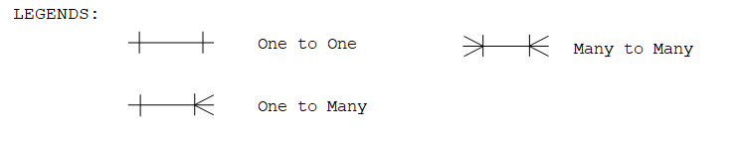

**Testing and Evaluation**

Software testing is the process of analyzing a software product to determine any discrepancies between delivered products and the input that was provided, as well as to assess the characteristics of the product. Testing evaluates the product's quality. Software testing is a procedure that needs to be carried out while the project is being developed. The developers themselves carried out the performance testing that was employed by the researchers. By using trial and error, it ensures the system's effectiveness, dependability, and availability within a certain time frame.

Additionally, web hosting, which allows users to share the website publicly, will be used to test the website. Once it has been tested online, the developers can assess whether certain features would provide an issue. When numerous accounts were connected to the database server, the researchers also looked for potential conflicts.

|  |  |  |
| --- | --- | --- |
| Scale | Range | Verbal Interpretation |
| 5 | 4.50-5.00 | Excellent |
| 4 | 3.50-4.49 | Very Good |
| 3 | 2.50-3.49 | Satisfactory |
| 2 | 1.50-2.49 | Fair |
| 1 | 1.00-1.49 | Poor |

**Table 3**

**Likert Scale**

The Likert Scale is depicted in the table and is used to scale responses in survey research.

**Implementation Plan**

The researchers have developed an implementation plan for the client. The system and related documentation are given to the project's backers.

For the agreement of the implementation conditions, a letter of agreement was prepared. The customer can speak with the developers about their concerns with the project, but the researchers will not oversee maintaining the system.

The tasks that must be carried out while designing the system were discussed throughout the implementation activities.

|  |  |  |  |
| --- | --- | --- | --- |
|  | Activities | Target date | Progress notes |
|  | Discussion with client | December 09, 2022 | Accomplished |
|  | Deployment Letter | December 01, 2022 | Accomplished |
|  | System Deployment and  Monitoring Period |
| s | Training for user |  |  |
|  | System Evaluation |  |  |

**Table 4**

**Implementation Activities**

The adoption of the system's implementation strategy is shown in the table. It acts as a manual for the users who would be responsible for system upkeep. The developers will provide end-users with training and lectures on how to utilize the built system before the system is put into use. The system will be maintained and monitored after it has been successfully established.